430 State St. Augusta, KS 67010
(316) 201-1099

www.sugarshanescafe.com
ssfivestarcatering@gmail.com
Five Star Catering by

Sugar Shane’s Café

Banquet & Catering
Menu

BREAKFAST

Continental Breakfast $7 per guest
Assorted muffins, pastries, breads with fresh fruit or yogurts

Breakfast Buffet $10 per guest
Scrambled eggs, bacon, ham or sausage & breakfast potatoes
Served with biscuits & gravy or breakfast bread
Add Cheesy Grits for $2 per guest

A La Carte
Yogurt $3 per guest
Bagels & Cream Cheese $3 per guest
Assorted Pastries $4 per guest
Mini Quiche assortment $105 per 100 pieces

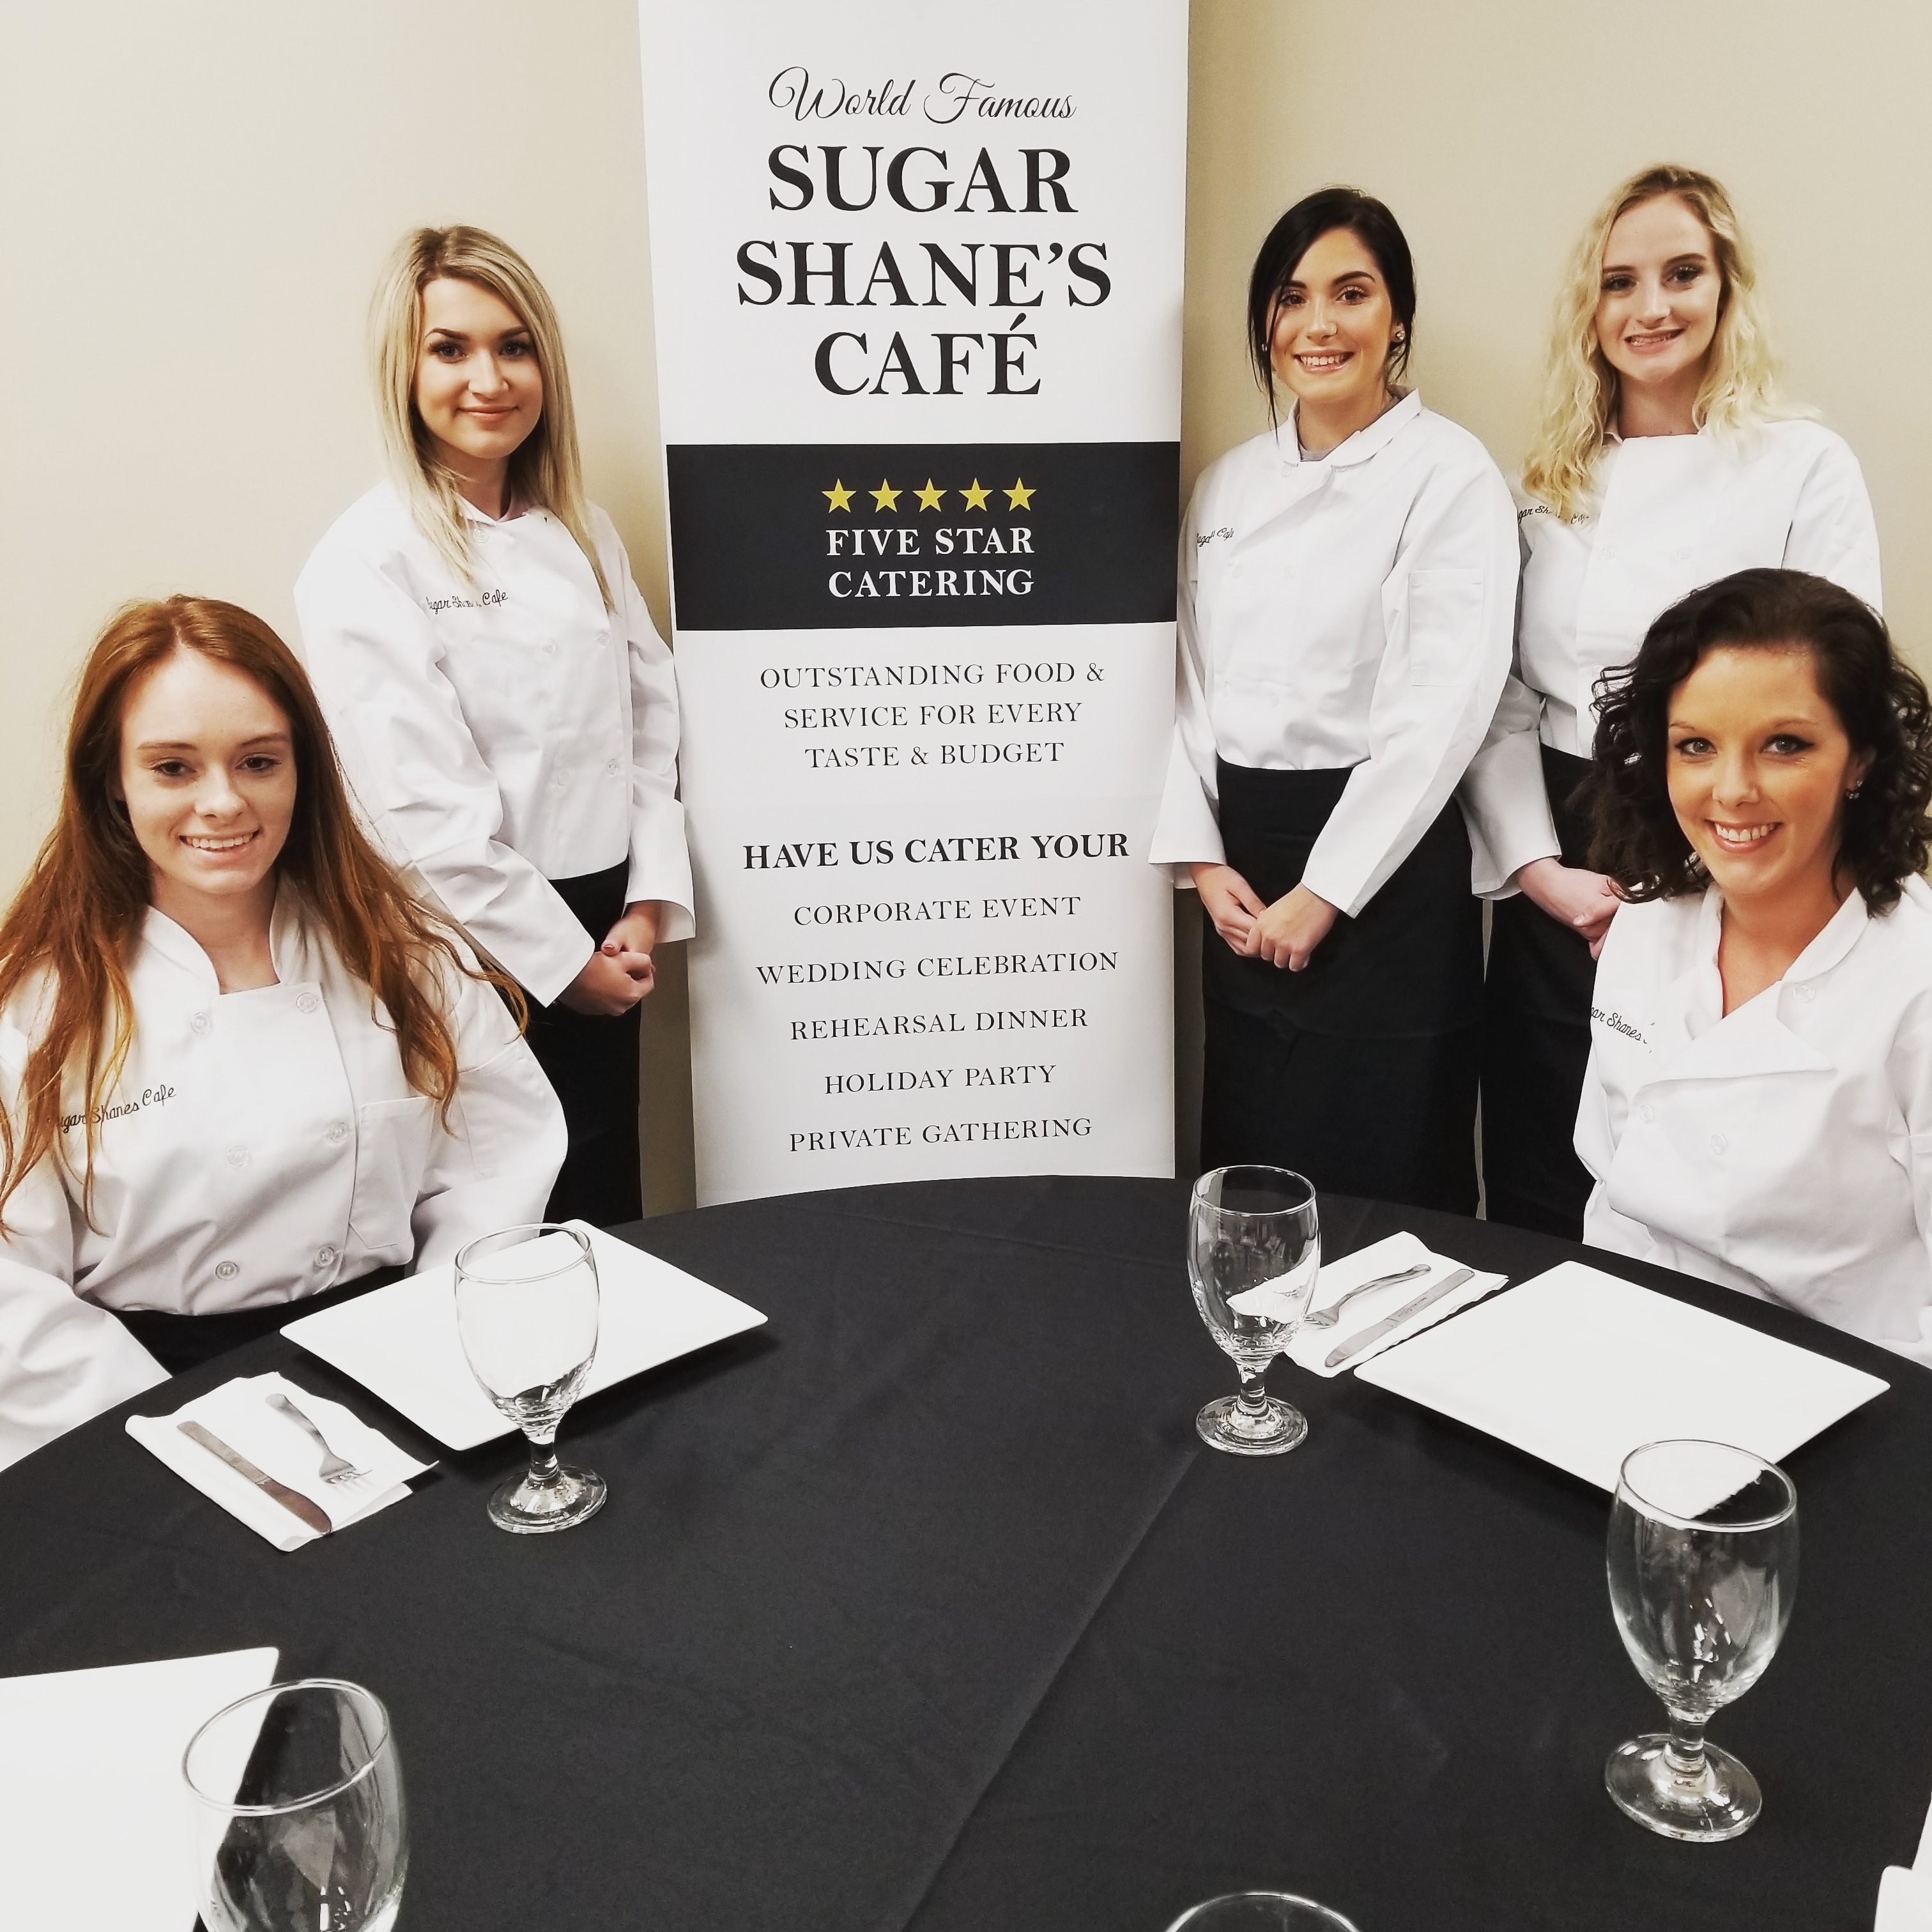

APETIZERS/COLD SELECTIONS
Create an appetizer buffet for your guests to enjoy
Full orders are based on 50 pieces

Chips & Salsa $70

Veggie Platter $75
Served with ranch dressing

Hummus Platter $75
Served with bread or chips

Fruit Kabobs or Platter $75

Pinwheels $80
Prepared with turkey or ham, or vegetarian style

Mini Chicken Salad Tacos $85

Cheese Platter $100
Cheese & Fruit Platter $110
Meat & Cheese Platter $125

Shrimp Cocktail Boat
Starting at $150

Charcuterie Boards
Starting at $195

APETIZERS/HOT SELECTIONS
Create an appetizer buffet for your guests to enjoy
Full orders are based on 50 pieces

Spinach & Artichoke Dip $75
Served with pita bread or tortilla chips

Meatballs $75
Tossed in your choice of BBQ, or Swedish

Hotlinks or Little Smokies $75
Served in BBQ Sauce

Egg Rolls $75
Asian or Santa Fe style

Spring Rolls
BLT, Cheeseburger or Philly Cheesesteak $85

Butterfly Shrimp $85
Breaded or Coconut

Cordon Bleu Bites $75

Stuffed Mushrooms $85
Cheese, herbs & spices
With Sausage $95

Bone-in/Boneless Wings $90
Served with a choice of sauces

Mini Crab Cakes $125
Served with our own special sauce

Sliders
Angus Cheeseburger or Pork Belly $150
Pulled Pork $140

ENTRÉE SALADS
All Entrée & Premium Entrée Salads served with Crackers or Bread. Add Grilled Chicken to any Salad for $2.50

House $8
Mixed greens, tomatoes, cucumbers, red onion & croutons. Served with your choice of dressing

Caesar $8
Romaine lettuce, shaved parmesan & croutons. Served with Caesar dressing

PREMIUM ENTREE SALADS

Greek $11
Mixed greens, feta cheese, tomatoes, cucumber & kalamata olives. Served with Greek dressing

Spinach $11
Baby spinach, strawberries, feta cheese, pecans, red onion & bacon. Served with Raspberry Vinaigrette

Italian $11
Mixed Greens, pepperoncini’s, black olives, tomatoes, red onion & parmesan. Served with Italian dressing
Add Salami $2

Caprese $11
Fresh mozzarella balls, tomatoes, & fresh basil drizzled in a Balsamic Reduction

SIDES

Potato Salad

Pasta Salad

Cottage Cheese

Mashed Potatoes

White Rice

Baked Potato with Butter

Corn

Green Beans

PREMIUM SIDES $3

Mixed Vegetable Medley

Grilled Asparagus

Baked Potato with Sour Cream, Bacon & Cheese

PASTAS
Our delicious pastas are served with House or Caesar Salad & Garlic Bread. Prices are per guest.
Add-ons: Grilled Shrimp $5 Chicken $2.50 Meatballs $2 Premium Salad $4

Macaroni $9
Macaroni pasta tossed in our homemade cheese sauce

Spaghetti $10
Spaghetti pasta topped with our homemade marinara, slow cooked with red wine,
garlic & fresh basil

Alfredo $10
Fettuccini pasta tossed in our rich & creamy alfredo sauce, topped with parmesan

Cajun Pasta $11
Red & green bell peppers, caramelized onion, & garlic in a creamy Cajun sauce

Baked Ziti $11
Penne pasta with ricotta cheese & fresh mozzarella, tossed in our own marinara sauce

Veggie Spaghetti $12
Spaghetti tossed in our homemade marinara with fresh sautéed squash, onions, mushrooms & savory roasted garlic

Green Chili Mac N Cheese $10
Mac N Cheese tossed in a delicious green chili sauce. Try it with grilled chicken or chicken tenders for $2.50

ENTREES
All Dinner Entrees served with one side, rolls & butter. Prices are per guest.
Add-ons: House or Caesar Salad $2 Premium Salad $4

Meat or Veggie Lasagna $12
Lasagna layered with mozzarella cheese & marinara sauce
(Comes with a house salad, not a side)

Chicken Piccata $12
Marinated grilled chicken topped with our lemon piccata caper sauce. Served with rice

Crispy Fried Fish $13
Flakey, hand battered fish, fried to golden perfection. Comes with coleslaw, tartar sauce & lemon wedges

Baked Chicken $13
Tender marinated baked chicken. Choice of mashed or baked potato with butter

Chicken Marsala $13
Marinated grilled chicken breast smothered in our house made mushroom marsala, served over mashed potatoes

Meatloaf $13
Our homemade meatloaf served with brown gravy. Served with mashed potatoes

Salisbury Steak $13
Savory Salisbury steak smothered in our delicious mushroom cabernet sauce. Served with mashed potatoes

Chicken Parmesan $13
Hand breaded chicken topped with our handcrafted marinara sauce, topped with mozzarella cheese & shaved parmesan. Served over fettucine

Jalapeno Pork Chop $13
Jalapeno flavor with just a little heat! Served with mashed potatoes

ENTREES

Sirloin Medallions $13
3oz sirloin medallions with mushroom cabernet sauce

Kabobs
Your choice of peppercorn sauce, mushroom cabernet sauce, or white wine cream sauce. Served over rice. Chicken $13 Steak $14 Shrimp $15

Hawaiian Chicken $13
Served with pineapple ring, rice & Teriyaki sauce
Try it served with the pineapple as your dish, prices vary per season.

Sliced Brisket $15
Marinated Brisket in our own special recipe. Served with not just one, but two sides.
BBQ Sauce or Beefy Brown Gravy

Fried Chicken $15
Tender marinated chicken battered in buttermilk & a special mix of herbs & spices then fried to perfection. Served with mashed potatoes & country gravy

Salmon $15
4oz-grilled salmon topped with your choice of bourbon or teriyaki glaze. Served over rice

Pan Seared White Fish with Shrimp $15
Grilled, seasoned White Fish topped with our very own White Wine Sauce with Capers & Grilled Jumbo Shrimp. Served over a bed of rice

Pork Tenderloin $16
Seasoned grilled pork tenderloin served with your choice of peppercorn, mushroom cabernet, or white wine sauces. Served with mashed potatoes

Prime Rib $25
Savory, oven roasted prime rib served with a side of house made au-jus & baked potato with butter

BUDGET BUFFETS
These are budget friendly buffets that come just the way described!

Taco Bar $9
Grilled Chicken &/or Beef with soft or crunchy taco shells, along with all the fixin’s.
Served with Spanish Rice or Black Beans & Chips with homemade salsa! Ole’!!

Hamburger Steak $10
Served with mashed potatoes, brown gravy & one side

Cajun $9
Chicken Gumbo, Red Beans & Rice & corn bread

Pasta Bar $11
Chicken Alfredo, Spaghetti with meat sauce served with house salad & garlic bread

Hotdog/Hamburger/Bratwurst $12
Your choice of any or all with buns, cheese, ketchup, mustard & pickle relish
Pick 2 for ½ size servings, Pick 3 for 1/3 size servings
Choice of chips, potato salad, pasta salad or baked beans

Simple BBQ $13
Pulled Pork, Chicken or Hot Link Bites.
Pick 2 for ½ size servings
Choose 2: Baked beans, Coleslaw, chips or potato salad
Bread and Butter, BBQ Sauce

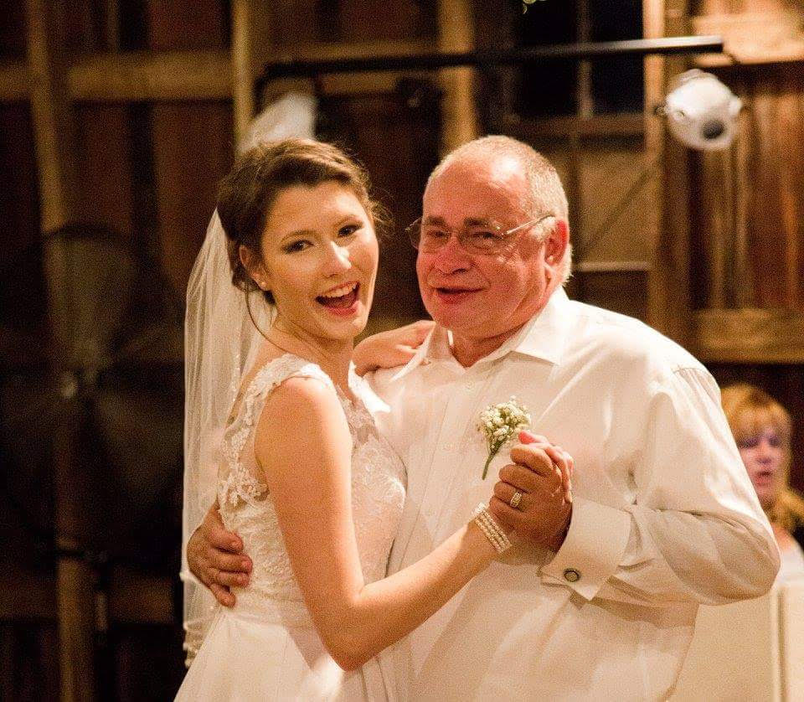

DESSERTS

Cheese Cake $4 per slice
Assorted Cookie Trays $30 25 pieces
Brownie Tray $30 25 pieces
Assorted Gourmet Cheesecake Pops $75 50 pieces

Bistro Mini’s $3 each
Reese’s Peanut Butter Pie
Turtle Cheesecake
New York Cheesecake
Chocolate Cake
Carrot Cake
Lemon Cake

Tiny Tidbits $2 each
Cherry Cheesecake
Chocolate Cake
Lemon Cake
Reese’s Peanut Butter Pie
Turtle Cheesecake
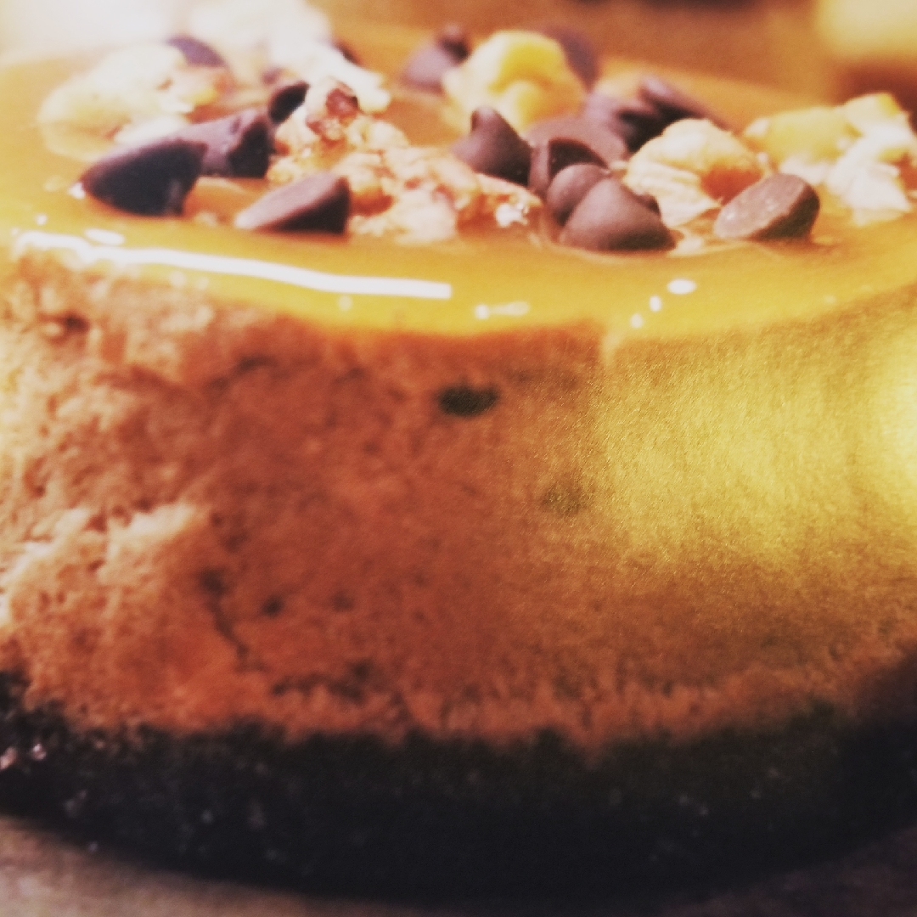
A LA CARTE & BREAK TIME ITEMS

Lemonade $15 per gallon
Iced Tea $15 per gallon
Coffee/Decaffeinated Coffee $15 per gallon
Chilled Fruit Juices $15 per gallon
Bottled Water $2.00
Assorted Soft Drinks $2.00 per bottle
$1.25 per can
Chips $1.00 per person
Snack Mix $1.50 per person
Whole Fruit Apples, bananas or oranges $1.00 each
Assorted Candy Bars $1.50 each
Nut assortment $10.00 per pound
Rice Krispy Treats $1.50 each

SERVICE WARE
Plates, Utensils & Paper Napkins as needed

Standard Disposable Serviceware .75 per person
Deluxe Disposable Serviceware 1.25 per person
Elegant Disposable Serviceware 2.25 per person
Containers for leftovers 1.00 each

BANQUET SERVERS

Server to help serve/clean up your event $15.00 each/per hour
Minimum 2 hours

ADDITIONAL INFORMATION & FEES

+ A 20% Deposit is required to book your catering. Dates are not held without a deposit. The deposit is applied to your final balance which is due 1 week prior to your event.

+ Cancellation not given 30 days prior to event will result in forfeiture of deposit.

+ You may notify us as late as 7 days prior to the event to alter your head count or information.

+ The final invoice will include tax, gratuity & a $25.00 delivery fee.

Contact Information

Sugar Shane’s Café
430 State Street
Augusta, Kansas 67010
316-201-1099

SSFIVESTARCATERING@GMAIL.COM

